

Dr. Todd, Hurst inc.
2017-10-02
Dr. Hurst
USNV Freeman, FPO AA 02175
Phone: 7938161868
Fax: 3074517784

Re: Nancy, Wilson
PHN: 593052783
Birthdate: 25-Dec-1999
Address: 223 Kellie Inlet, Port Edwardchester, SD 13515
Patient number: 3728778947

To Whom It May Concern:

This is a medical letter to state the above patient is pregnant with expected delivery date of 08-Jun-2025. Hoping this information is satisfactory for your requirements.

Thank you.

Sincerely,
Dr. Todd, Hurst
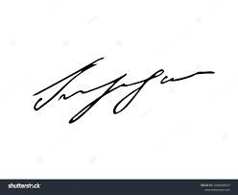
FRCS© NCMP
Clinical Assistant Professor, UBC
Department of Obstetrics and Gynecology SMH

